Use of the Portable Scanning Force Microscope for On-Site Inspection of Gas Turbine Blades for Condition/ Life Assessment

Acronym: ‘SFM for GT Blades’

ETD Proposal No: 1944-tp-prop23

(Proposal for a Multi-client or Group Sponsored Project – GSP)

Proposal Prepared by:

Dr H Wang, Dr A Shibli

January 2024

BACKGROUND AND INTRODUCTION

For the Fitness-for-Service and remaining life assessment of an operating Gas Turbine after service, the metallurgical condition of the hot gas path (HGP) components is usually examined with the evaluation of the microstructure degradation. The assessment result, along with other damage features found by NDT, are the basis for a run-repair-replace decision to be made for the gas turbine unit concerned.

Experience shows that gas turbine blades (or buckets) from the turbine section are often the life-limiting HGP components due to the typical harsh operating conditions, including high-temperature and complicated stresses. For those turbine blades, including some vanes (or nozzles) made in nickel-based superalloys, such as IN738L, the microstructure of the gamma prime γ’ precipitation-strengthening particles is conventionally examined in the laboratory on metallography samples by means of high-resolution Scanning Electron Microscope (SEM). Typical microstructural features, such as the morphology (cuboidal or spheroidal) and size of precipitates, are observed and recorded.

The present proposed development work aims to develop a new method for the on-stie examination of Ni-based gas turbine blade gamma prime microstructure conditions, by means of a portable SFM (Scanning Force Microscope). In contrast to the SEM method, this work aims to develop an alternative method with the SFM instrument that is mobile (without the constraint of the vacuum-based SEM operational environment) and non-destructive (without the need to prepare metallography samples which means dissecting the blades).

OBJECTIVES OF THE PROJECT

Th primary objective is to investigate the use of portable SFM for on-site inspection of GT blades via the following achievements:

- To demonstrate: By investigating and optimizing the SFM imaging conditions using metallography samples to be taken from a number of blades / or pieces for a number of blade chemistries and / or operation histories (this involves blade cut-up).

- To scale up: By investigating and demonstrating the SFM on a full blade for its inspection capability of the gamma prime microstructure of a selected blade from its surface, non-destructively and with minimum necessary surface preparation and etching (this does not include blade cut-up).

TECHNICAL

3.1 Turbine blade test materials

ETD will need to access a number of GT blade pieces from some of the project sponsors for laboratory studies, more specifically:
- The blade must be in Ni-based superalloys in those grades that are gamma prime precipitation-strengthened (this will exclude solid solutioning Ni-base superalloys such as Inconel 600).
- The blade can be in one piece, or in pieces (if these are left-over from previous cut ups). For this project at least one whole blade will be needed.
- It is desirable but not essential, that the blade chemistry and operation history are known.

3.2 Use of Scanning Force Microscope

Portable SFM development and use
The ETD portable Scanning Force Microscope (SFM) is a development on the traditional lab-based Atomic Force Microscope (AFM) that allows the technology to be used in a plant environment to produce nano-scale resolution images of comparable detail to Scanning Electron Microscope (SEM) images. It uses the same preparation steps that traditional replication uses but is able to resolve much finer features in three dimensions. This 3D approach allows for the confirmation of very small cavities that cannot be detected using traditional replication. SFM is also used for the study of precipitates in high temp. creep alloys. Images below show the original use of the SFM by ETD to study early stage creep cavitation in high Cr martensitic steels.

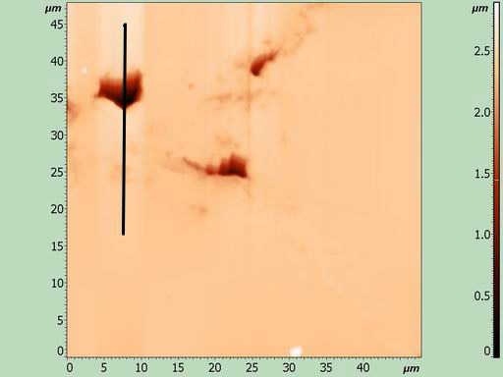 | 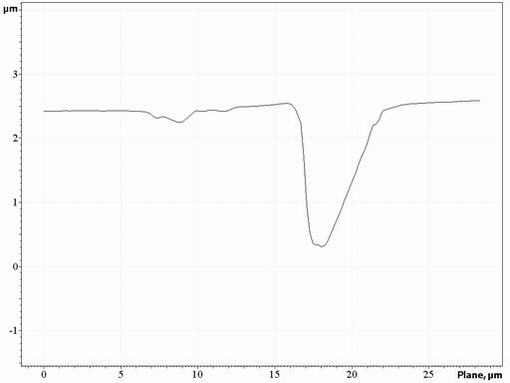 | 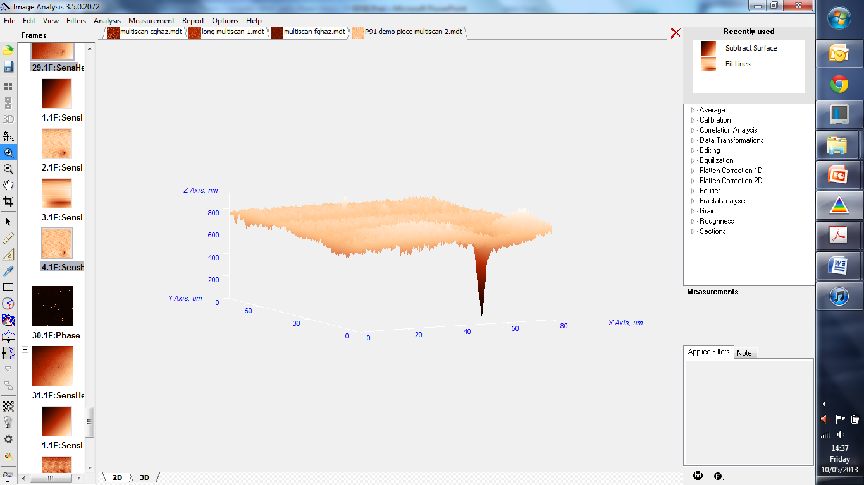
SFM image taken from an un-etched P91 weldment showing three cavities | Line scan showing the depth of the larger cavity | Three dimensional image of a creep cavity

SFM trials for the study of γ’ precipitates in a GT blade
For the GT blades some preliminary work has been carried which has proved very encouraging. The micrographs below show the unaffected cold root of the blade fixing and the leading and trailing edge microstructures, showing promising potentials of SFM for gamma prime examination.

This project will aim to optimise the etching and SFM investigation parameters to achieve high resolution images and their relationship with the blade condition.

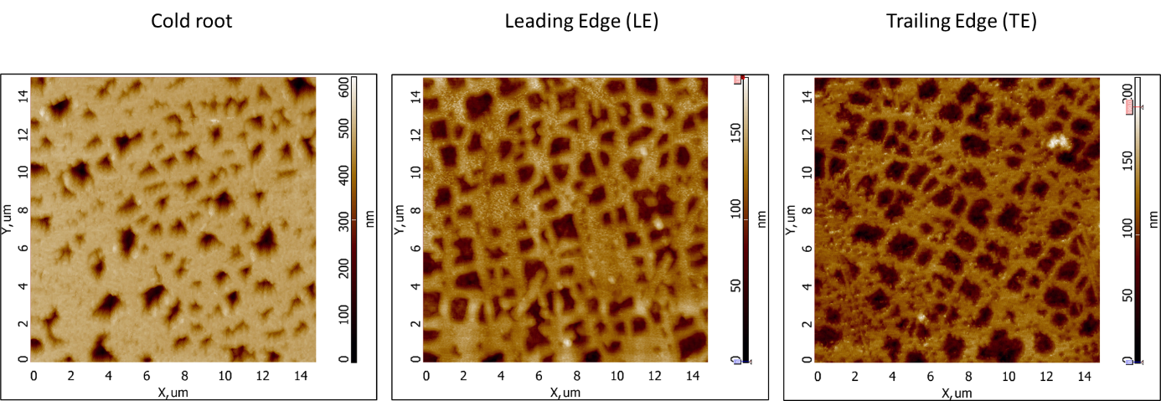

TIMESCALE AND DELIVERABLES

The work will be carried out over an estimated period of 6 months, with 1 additional month for contingency, and is planned to commence in early 2024. The schedule of activities is listed in Table 1.

In terms of deliverables, brief progress report will be issued at Month 3 and the sponsors will be kept updated of any developments or significant results and findings at any other time. The Final Report will be issued soon after month 6.

The main deliverable will be the Final Report, reviewing the work performed, all significant findings and recommendations on the use of the SFM for on-site GT blade inspection.

Table 1: Project schedule

PROJECT BENEFITS AND COST

Sponsors joining this project will get a full understanding of the SFM as the novel inspection technique for GT blade inspection. If satisfied ETD will be happy to offer this service to the project sponsors on a priority basis.

The cost to a sponsor for joining the project is only a few thousand pounds which will be communicated to those showing interest in joining this exciting development.

Note: One of the main benefits of joining a Group Sponsored Project (GSP) is that the project cost is shared between a number of sponsors. As a result, each sponsor contributes only a fraction of the total cost although he/she gets the full benefit of the outcome, thus making it an excellent value for money. The other benefit is the sharing of experience and knowledge between the project participants/ sponsors.

If this technique can be optimised through this small project, which looks very likely due to the encouraging results from the preliminary work briefly shown above, then this will bring a huge amount of benefit to the GT manufacturers, GT Operators, and plant owners in that costly GT blades will not have to be sacrificed for in-lab. destructive study.

7. FURTHER CONTACTS
Should you require further information, please contact:
For Technical Matters: Dr Hong-Wei Wang at: hwang@etd-consulting.com
For Commercial Matters: Mr Ignacio Rivera at: irivera@etd-consulting.com

8. COMPANY PROFILE AND SERVICES

European Technology Development (ETD) is an independent company registered in England. It is a highly innovative engineering and consulting company engaged in life assessment and life extension of power, petrochemical, refining, chemical and other high-temperature plant. ETD’s consulting services are backed up by state-of-the-art collaborative R&D work and technology development that the company is involved in. Development of new high-temperature materials and assessment of their integrity, defects/cracks, welded structures, failure assessment and plant Risk Based Maintenance are of particular interest to the company.

The company works through a pool of internationally known technical experts with background and expertise in Plant Services and R&D in energy, petrochemical and other industry sectors. The company has close links with various national and international technical bodies and standards committees. ETD staff have carried out integrity and life assessment of many power and petrochemical plants including steam-raising plant for chemical industry.

ETD provides Asset Integrity Services to support continued operation of ageing plant, to quantify the remaining period of safe operation, and advice on inspection, maintenance, repair or replacement strategies. It also regularly provides advice to its plant design and manufacturing clients on innovations in plant design to help them build new high efficiency plants.

In addition, ETD’s Asset Integrity Services include:
- Defect/crack assessment
- Structural stress analysis
- Fitness-for Service
- Weld assessment and weld repair issues
- High-temperature corrosion in industrial environments
- Use of new materials (P91, P92, P23, P24), Ni-based alloys and super stainless steels for newer generation of power plant
- Issues affecting petrochemical, refining and process plant.

ETD’s Plant Consulting Services include provision of expert support in:
- Materials advisory and selection service for all types of high-temperature plant.
- Root cause analysis of component damage and failures.
- Repair and replacement strategies.
- Risk Based Management/Maintenance / outage planning, inspection and plant overhaul management.
- Plant cycling and maintenance – issues and cost analysis for power plant subjected to steady load and cycling duties.
- Benchmarking and efficiency improvement of power plants.

ETD’s client base includes, for example, companies from UK (Killingholme Power, Mott MacDonald, Derwent Cogeneration, Alstom Power / GE, Barking Power Station), Ireland (ESB, Huntstown PP)), Canada (Ontario Power Generation, Sask Power, TransAlta, CEATI), Belgium (Engie and Engie Laborelec), Italy (ENEL, Inail, Ansaldo), USA (EPRI, Progress Energy, InterGen, Vogt Power/Babcock Power), South Africa (Eskom, Sasol), Germany (E.ON, Siemens), Japan (Kyushu Electric, Mitsubishi Heavy Industry, IHI, Nippon Steel, Central Electricity Research - CRIEPI) and many more.

ETD carries out both plant services/ consulting and international industry collaborative R&D projects, hence the company can draw on the expertise of its R&D staff to provide best advice and innovative solutions to industrial problems when providing plant services consultancy. Many of the company’s collaborative R&D and Technology Development Projects are sponsored by international industry and other organisations as single sponsor (Third Party), or Group Sponsored Projects (GSP). Two examples of recently completed GSPs related to creep damage and inspection of P91 steel are:

- Development of Inspection, Monitoring & Life Assessment Techniques & Guidelines for Welded P91-P92 In-service Components

- Creep Rupture Strength of ‘Abnormal P91’ Materials and Welds

Further details may be found at the company website: www.etd-consulting.com

--------------------------------------------------------------------------

