MIMA- 4 Int. Conference

Updated: 27 August 24

Decarbonisation of Power Generation
International Conference - London
MIMA-4

Use of low or no carbon fuels in new and existing fossil power plants and their flexible operation in conjunction with the renewables and nuclear plants, including fossil and renewable plants inspection, monitoring, repair and life assessment issues
================================================

Venue: Woburn House, 20 Tavistock Square, London www.woburnhouse.co.uk
(a few minutes walk from Euston, Kings Cross & St. Pancras Train & Underground Stations)
Dates: 15 - 17 April, 2025

Announcement, Registration Form & Call for Papers
Abstract submission by: 29 November 2024
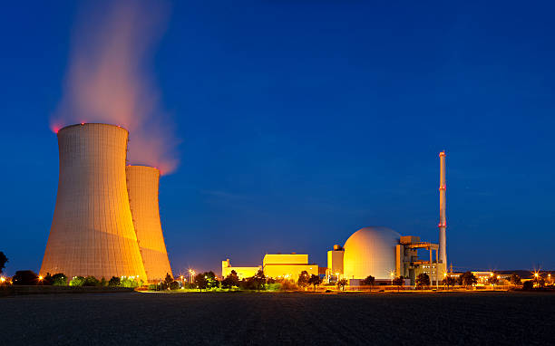 |  |  | 
 | 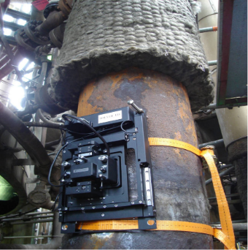 |  | 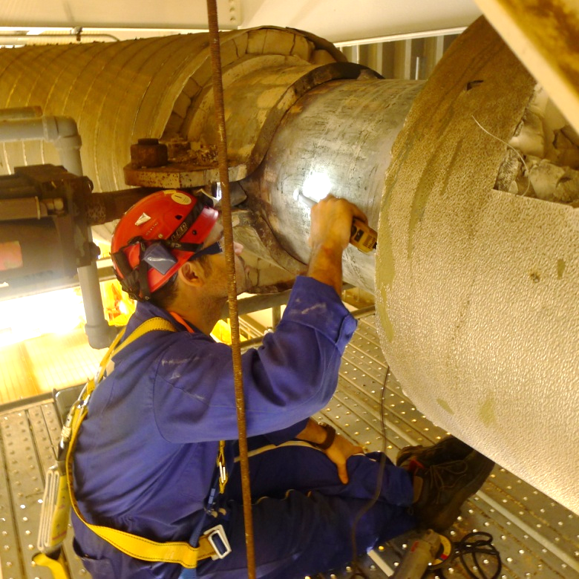

SPONSORS

Sponsorship is invited from industry, service providers and other interested parties. Different level sponsorship is available. In the first instance please write to: enquiries@etd-consulting.com

CONFERENCE OBJECTIVES
International Conference - London
MIMA-4

The aim of this conference is to provide an international platform for the exchange of knowledge and experience related to various fossil power generation plant issues including their decarbonisation (both new generation and existing plants) using low or no carbon fuels as alternatives to coal and gas. These fuels could include hydrogen, ammonia, E-fuels, renewable diesel, pyrolysis etc. With the use of new fuels come the technical and costs issues of their production, storage and transportation etc. and the introduction of the new damage type to the materials used and to the power generation plant boilers/HRSGs and turbines. This requires a deeper understanding of the inspection, monitoring, safe operation and condition/life assessment of the structures involved.

The other topics which have currently gained much significance area the fossil power plant flexible operation in view of the increasing intervention of the renewables, digitalisation of the power industry, SMRs - Small Modular Reactors, the challenge of the fabrication and inspection of newly developed materials for the new generation of fission and fusion nuclear power plants and for wind turbines. These will also be discussed in this three-day event.

The main theme is how to make power generation more environmentally sustainable.

Note: ETD is currently involved in large scale studies for its industry sponsors on the de-carbonisation of fossil power plants and hence particular interest in this conference theme.

CONFERENCE FORMAT/ ORGANISATION / PRESENTATION TIMES
The Conference will principally consist of presentations of 25 mins. each, including about 3 mins. for questions/answers. Keynote presentations will be of 35 mins. duration including about 3 mins. of questions/answers and will normally cover an overarching theme or subject.

WHO SHOULD ATTEND ?
Plant owners/operators, owners, designers, fabricators, inspection companies and service providers will be the prime audience in this conference. It is also envisaged that other organisations such as research institutes and universities will equally benefit from this experience and the information exchange.

SUBMISSION DEADLINES
Abstracts: The deadline for the submission is Friday 29th November 2024. An abstract should consist of a couple of paragraphs stating what the presentation is about and the areas that it will cover.

Presentations: The deadline for the submission is Tuesday 1st April 2025. ETD will aim to provide the presentations as Conf. Proceedings (in the pdf format) to the attendees a few days before the start of the conf. to ensure that the attendees get maximum benefit.

Papers (Optional): As the Conf. is aimed at industry, submission of papers is optional. Those which are submitted will be referred for publication to the journals and can also be included in the Conf. Proceedings if the presenters so wish and if they are submitted by 1st April 2025.

All Submissions (& Technical Enquiries to):
Dr Ahmed Shibli ashibli@etd-consulting.com Tel: +44 788 109 7730

Administration Related Enquiries (including registration) to:
enquiries@etd-consulting.com

The Organiser
International Conference - London
MIMA-4

European Technology Development (ETD)

ETD is an independent UK based engineering, consulting and R&D company specialising in high temperature plant inspection and life assessment /extension, maintenance, materials and engineering issues in power generating and petrochemical/process plant. ETD has, in the past, organised various international workshops/ courses/ conferences in the UK, Europe, USA, Canada, South Africa, Japan, Korea and other countries of Asia, mainly on the issues dealing with power and process plant life assessment/ extension, high temperature plant materials, plant component safety and durability, performance of in-service welds, fossil power plant cycling, risk-based maintenance (RBM), Reliability Centred Maintenance (RCM), probabilistic life and crack assessment, weld repairs, inspection and life assessment of newer martensitic steels such as ASME P91, P92. etc.

More recently ETD has been studying the use of hydrogen and ammonia as alternative fuels for the existing and future fossil power plants. The other fuels being investigated by ETD are the those for the future commercial use, such as e-fuels, renewable diesel, pyrolysis etc.

The company has been leading and co-ordinating a number of large cutting edge international industry projects (supported by the industry from North America, Japan, Europe and elsewhere or by the UK government and European Commission) on issues related to the assessment and improvement of high temperature plant performance, materials and design, maintenance and inspection strategies, and the development of innovative inspection techniques. The company has been carrying out/ leading edge projects on P91 and P92, weld repairs, crack assessment, FFS and fossil power plant flexible operation.

For more than quarter of a century now ETD has been carrying out full inspection and integrity/ life assessment of power and process plant worldwide - especially in Europe, Far East, Middle East, Africa and Australasia.

The company has developed its own unique equipment (in collaboration with industry in Europe and Japan) such as a portable spark erosion machine for ‘boat sampling’, a portable AFM for early-stage on-site creep cavitation damage detection in P91/ P92 and GT components, a precision portable hardness tester called ‘Smart Sleeve’ etc.

Further information on ETD, its consulting services, full plant inspection and life assessment, training courses offered and other activities can be seen at: www.etd-consulting.com

International Conference - London
MIMA-4
Presentations are invited on the following (or related) topics

- Use of Hydrogen and Ammonia in CCGTs - Production, transmission, storage and damage to metallic structures and GTs/ STs and Boilers/ HRSG components of the power plant. Both technical and cost issues.

- Use of the Alternative Fuels of the future (Pyrolysis, E-Fuels, Renewable Diesel etc.) and associated technical and cost issues.

- Flexible Operation of Fossil Power Plants (Conventional and CCGTs) in view of the increasing use of renewables and their intermittent nature - both Technical (materials, inspection, monitoring and condition/life assessment etc.) and Cost issues.

- Renewables - wind, solar, hydros etc. - materials, inspection, repair and recycling issues.

- Nuclear Power Generation. Fission (Gen. IV), Fusion, Small Modular Reactors - cost of power generation, materials, inspection, life assessment and related issues.

BOAT TRIP ON RIVER THAMES & BBQ DINNER (Wed.16 April 1900 – 2200 h) (4 hours)



International Conference - London
MIMA-4
REGISTRATON FORM
Please complete and email to: enquiries@etd-consulting.com

International Conference: Decarbonisation of Power Generation

Materials, Inspection, Monitoring and Assessment (MIMA-4)
Venue: Woburn House, 20 Tavistock Square, London www.woburnhouse.co.uk

Dates: 15 – 17 April 2025

Registration Fee: Please put ‘x’ in the relevant box and show the total payment.
Fee is to be paid in GB Pounds. (all those attending in-person events held in the UK need to pay 20% VAT).
Fee to be paid is shown in bold.
International Conference - London
 | Reduced Fee (Until 17 March 25) | x | Full Fee  (From 18 March 25) | x
Conference Delegates | £500+100 VAT = £600 |  | £550+£110 VAT = £660
Conference Presenters | £400+£80 VAT = £480 |  | £400+£80 VAT = £480
Delegates (part-time)  Day rate (boat trip + dinner extra @ £50 per person. | £200 +£40 VAT= £240 |  | £225 +£45 VAT= £270
Please show here no. of attendees x £ Total Amount Payable = £
(For part time attendees please
show which days + boat cruise & dinner, if applicable).

Conference Registration Fee covers: Organisation of the Conference, provision of the Conference Presentations in electronic format, lunches, coffee/ tea during the breaks and boat trip on River Thames including the conference dinner on the boat.

----------------------------------------------------------------------------------

How to Pay: When paying please quote reference ‘MIMA-4 Conf.’ and the ETD invoice number (if this was issued):
- By bank to bank transfer to: European Technology Development Ltd.
(ETD bank account details will be provided on request)

- Credit Cards: Payment information will be provided on request.
When registering, please state here how you paid or intend to pay:
…….........…………………….….……………………..........................................
.................................................................................................................................

Delegate/ Speaker Details
Name: | Job Title (optional):
Company: | Address:

Please email Registration Form, including all enquiries, to: enquiries@etd-consulting.com

