
Reliability Centred Maintenance 4th Generation
RCM Gen.iv

Online 3-days TRAINING COURSE

Effective Maintenance and Reliability Strategies for Fossil Power Plants with Base Load, Peaking and Cycling Power Generation

Acronym: RCM 4th Generation

Dates: 11-13 December 2024

Venue: Online (from London)

A comprehensive practical course on Maintenance and Reliability Excellence Framework Program Development and Implementation, APMS (Asset Performance Management System), RCM 4th Generation, RBI and SIL integration in power generation industry and customer specific equipment discussions in Generation and Distribution.

 | 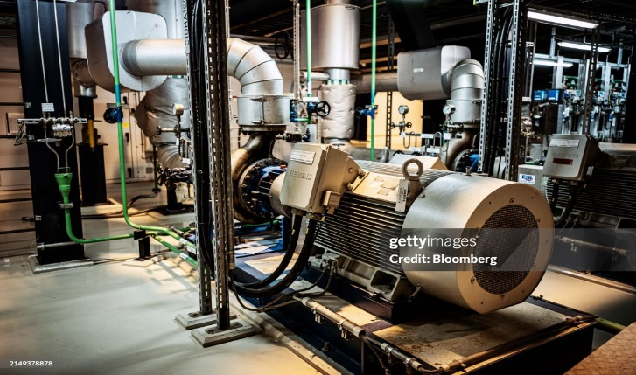 |  | 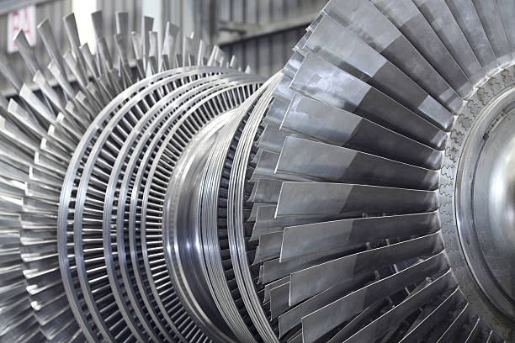
Key Focus
- RCM 4th Generation Philosophy
- FMECA Approach, Maintenance Strategies Optimization
- MTO-Mitigating Assets Threats to Opportunities
- ECP- Equipment Care Program
- BAP- Bad Actor Program
- RBI-Risk Based Inspection Programs
- SIL- Safety Integrity Level
- Proactive CBM – Condition Based Maintenance
- RRM – Risk and Reliability Management Framework Roadmap
- RCM, RBI and SIL KPIs
- Maintenance Efficiency Index
- Reliability Framework Development and Implementation
- Performance and Functional Based M&R program
- Critical Equipment Discussions, Criticality Evaluation
- RLA- Remaining Life Assessment
- CMMS- Computerized Maintenance Management System

Course Description
Assets operations and maintenance are paramount to overall effectiveness of business objectives ensuring minimum downtimes and maintenance cost optimization. The variety of Fossil Power Generation Equipment such as Gas Turbines, HRSGs, Boilers, Steam Turbines, Generators, Boilers, Control System and Distribution Grids bring certain complexities when identifying problems and conducting the specific maintenance requirements.

This 3-day program is designed to assist the maintenance and reliability management, engineers and technicians in identifying the various Operating Performance and Functional parameters, Generation Reliability considerations as part of RCM 4th Generation program development and implementation, Criticalities and Failure modes, consequences and mitigation characteristics.

The program is specifically designed for discussion on New, Medium Aged and Aged fossil Power Generation Assets and will help participants in developing a Proactive Maintenance and Reliability program, effective strategies with embedded RCM 4th Generation methodology & implementation for the whole Assets with emphasis on Specific Equipment plans. Participants will also be provided understanding of Preventive and Predictive Maintenance programs with analysis of Condition Monitoring data and further corrections in Maintenance Program, introduction of RRM – Risk and Reliability Management for optimization of the Generation Assets Maintenance schedule.

Generation Assets Bad Actors management programs with emphasis on Trips, Performance variations, Load Cycling its effects, Forced Outages, Turn Around Work-Scopes Optimization techniques will supplement the course with practical exercises.

A thorough insight into the Reliability Framework Current Practices GAPS and resolution, Maintenance cost and life cycle analysis will supplement the course. Remaining Life Assessment, Evaluations and Recommendations and Equipment Repair and Replacement decisions as part of Generation and Distribution process will be discussed in depth.

The Asset management model as applied to Power Generation Assets equipment as part of RCM 4th Generation strategies will be discussed in detail with reference to ISO 55000-1.-2 recommendations.

Who Should Attend

- Power Generation and Distribution Operations and Maintenance Management
  - Managers, Engineers, Chief Engineers, Vice Presidents
- Maintenance Staff
- Maintenance Planning Managers
- Maintenance Program Engineers
- Reliability Engineers / Managers
- Finance and Procurement Managers

Course Benefits
- Understanding Performance and Functions GAPs in PG Assets
- RCM 4th Generation Understanding & Standards ISO55000, SAE JA1011/2
- FMECA Approach in Optimizing PMRs- Preventive Maintenance Routines
- Criticality Analysis and Maintenance Strategy Alignment
- Maintenance and Reliability Excellence Program Development and Implementation.
- Power Plant Performance GAP Analysis
- Power Plant Major Checks, Rotor, Boiler Assessments
- Equipment performance Evaluation throughout life Cycle
- Understanding Life Extension Evaluation and Recommendations
- Understanding Equipment Key Maintenance Performance Indicators
- Power Plants Bad Actors Management, Analysis
- Operational Cost Monitoring and Analysis
- IEEE 762 Reporting Guidelines
- Systems & Equipment Repair vs. Replacement decision
- Improved job performance, Decision making capabilities.
- Technology transfer between participants.

Learning Objectives
After completing this course, participants will be able to understand:
- Generation Performance and Functional Standards
- Advance Maintenance and Reliability Management in Power Plant
- Eliminate UPDT unplanned down time, Forced Outages.
- Optimization of Maintenance Strategies and Tasks
- Latest innovations in RCM, FMECA, RCFA, RBI, SIL and CM for Generation
- RCM 4th Generation Implementation strategies for success
- Implement Solutions that reduce the cost per hour of operation
- Optimize performance and efficiency using CBM & Diagnostics Approach
- Effective reliability program to optimize the performance of the assets
  - Practical case studies to evaluate and adopt solutions in Generation Setup
  - Appropriate analytical tools for maintenance decision making.
===============================================
Training Methodology
The training will be facilitated using modern techniques, supported by case studies from real Power Generation environment and videos. The Analysis tools application to maintenance, reliability and failure analysis will be exercised with mini workshop within the sessions.

Note: Participants should use their laptops to use analysis software with their own Asset data. Repair vs. Replacement decisions on specific equipment will be exercised during the course.
====================================

ABOUT THE ORGANISER

European Technology Development Ltd. (ETD), UK

ETD is a UK based engineering and consulting company specialising in life assessment/ extension, maintenance, materials and engineering issues in all types of power generating and process plant. In addition to its main business of technical consulting, plant inspection and their condition and life assessment, ETD regularly organises training courses in power, petrochemical, oil, gas and other industrial sectors as a part of its programme on technology transfer to industry worldwide. In the recent past ETD has organised various international workshops/ courses/ conferences in the UK, a number of other European countries (Germany, France, Portugal), Middle East, Far East, South East Asia, Canada and the USA.

For further information please visit: www.etd-consulting.com
Or, write to: enquiries@etd-consulting.com

We have added optional 30 minutes at the end of each day for discussion and question/answer session.

DAY 1 (Wednesday, 11 December)

Join MS Teams at: 0745h - using Teams link provided before the course start date.
Times shown are UK, please make sure that you know the right time in your zone.

(0745-0800h UK Winter Time) Welcome and Introduction to the Day’s Proceedings

0800-1130h (UK time) + 30 mins. optional at the end for discussion

- Understanding Generation Types and Designs
- Performance and Functional Variations on Power Plant Assets
- Understanding RCM 4th Generation Program and its Historical Development
- Identifying the Power Generation Asset for RCM 4th Generation Implementation
- Power Plant Performance GAP Analysis, Functional and Financial Gains through RCM.
- Complete Understanding of Maintenance and Reliability Strategies and Philosophies.
- Defining Critical Systems / Equipment / Components.
- GTs, Boilers, HRSGs, Generators, Steam Turbines, Miscellaneous Systems
- Identifying Functions of Critical Systems / Equipment / Components
- Criticality Analysis, Review of PG Asset, FMECA, RAMs
- Performance vs. Functional Reliability,
- Calculating Reliability, Availability & Maintainability (Practical Exercises).

Two Coffee Breaks (15 mins. each) at about:

0900-0915h and 1015-1030h

-----------------------------------------------------------------------

1130 to 1200h – Optional: Discussion and Question /Answer Session

=================================================================

DAY-2 (Thursday, 12 December)

Join Teams at: 0745h (UK time)

(0745-0800h) Welcome and Introduction to the Day’s Proceedings

0800-1130h (UK time) + 30 mins. optional at the end for discussion.
- Identifying Functional and Performance Failures / Failure Modes, Consequences
- P-F Intervals Analysis, Reviewing the RCFA Studies, Recommendations Management
- Identifying Critical TAGS on Power Generation Assets
- Maintenance Costing, CAPEX and OPEX Vs LTSAs
- Understanding Mitigations Like Additional PM (Preventive Maintenance) Tasks & RBIs
- Reliability Framework Development & Implementation
- Critical Performance and Condition Monitoring TAGs identification for PG Assets
- Evaluation Existing Maintenance and Reliability Programs
- Developing of Maintenance and Reliability (KPIs) and GAPs Measurement
- Weibull Analysis, MTBF, MTTR, MTTF for PG Systems/ Equipment
- RAM / RBD Model Parameters Evaluation
- Understanding Existing CMMS History and Review for GAPs
- IEEE 762 Reporting on RAMs & Productivity.
- ECP- Equipment Care and Plant Threats Integration.
- MTO Short-Term and Long-Term Mitigations / Modifications Requirements
- Plant Bad Actor Management Programs

Two Coffee Breaks (15 mins. each) at:

0900-0915h and 1015-1030h

----------------------------------------------------

1130 to 1200h – Optional: Discussion and Question /Answer Session

DAY-3 (Friday, 13 December)

Join Teams at: 0745h (UK time)

(0745-0800h) Welcome and Introduction to the Day’s Proceedings

0800-1130h (UK time) + 30 mins. optional at the end for discussion.

- Mechanical, Electrical, Instrumentation and Condition Monitoring PM Task Analysis
- Effective use of Maintenance Historical Data Base
- Use of Software Systems in RCM/RAM Analysis, CMMS Challenges
- RCM 4th Generation Equipment Specific Case Studies (Mini Workshops)
- Redefining Maintenance Tasks and Strategy for Reliability Improvement in PG Assets.
- Making RCM 4th Generation, RBI and SIL a Success Asset-wide, Developing a Culture.
- Extending RCM 4th Generation study into RLA study for Plant Assets/Systems
- Additional Specific recommendations for Quality and Condition Monitoring for RCM 4th Generation Success in PG Assets
- Review of LTSAs

Two Coffee Breaks (15 mins. each) at:

0900-0915h and 1015-1030h

(1130 to 1200h) – Optional: Discussion and Question /Answer Session
=======================================================

COURSE PRESENTER


S. Nadeem Ahmed
Asset Performance Management System
RAM/ RCM 4th Generation / MSG-4 Applications Specialist
M.Sc. Engg Th.PE / Six Sigma MBB

Syed Nadeem Ahmed has diverse professional engineering experience of more than 30 Years with demonstrated ability to Develop and Implement an Asset Performance Management System in Power Generation, Process & Petrochemical and Aviation Industry. Plant Performance Benchmarking and Improvement studies.
He has a Masters degree in Thermal Power Plants Engineering with Six Sigma MBB Analyst qualification. Qualified Reliability Program Development MSG3 Certified.
Mr Ahmed has facilitated more than 200 Events on Maintenance and Reliability Programs, RCM 4th Generation, Plant Performance and APMS across the globe in Power Generation, Process /Petrochemical and Aviation Industry.

Key Specialities include:
- APMS – Asset Performance Management System development and implementation for power, process and petrochemical plants
- Leading RAM/RCM/MSG3 based Studies for Plant and its Equipment, Maintenance Strategy deployment, Failure Elimination strategies and Reliability Analytics
- Performance optimizations studies for Power, Process and Petrochemical Plants
- Asset Integrity Assessment/ Remaining Life Assessment (RLA) study of Petrochemical and Power Generation Plants
- Process & Petrochemical Plant Debottlenecking and Performance Optimization study
- Maintenance and Reliability Program Development and Implementation in Industrial Plants
- RMF - Reliability Management Framework development and implementation in Industrial Plants
- MSG -3 Maintenance Steering Group Program Implementation in Industrial Plants
- Work-Processes development, Procedures and Guidelines development, Criticality and GAP Analysis for plant and its equipment.
- Technical Training Development and Facilitations- Plant and Equipment Specific
- RCM 4th Generation Integrator with MSG3 program for Aircraft & its Systems.

Key Competencies

- Plant Life Cycle Asset Management Strategies.
- Plant Asset Performance Management Standards Implementations, Reliability Analysis & Risk Based Studies.
- RCM 4th Generation based Maintenance & RMF - Reliability Program Development and Implementation.
- Work-scope Optimization on Plant Equipment Maintenance. Repair & Overhaul
- Equipment Failure Analysis RCAs, RBD Modelling, FMECA, RCM 4th Generation Program etc.
- Advanced RAM / RCM 4th Generation Study for Plant, Systems, etc. PM Program optimization
- Focused Lean Six Sigma Trainings (Black Belt Level) for Plant Maintenance and Reliability Professionals.

===============================================

Reliability Centred Maintenance 4th Generation
RCM GEN. IV

REGISTRATION FORM

(Please email the Form or simply email your details, days of attendance and amount paid/to pay)

3-days Online Training Course

Effective Maintenance and Reliability Strategies for Fossil Base Load, Peaking and Cycling Power Generation
Dates: 11 – 13 Dec. 2024

Registration Fee: Covers delivery of the course & provision of presentations in pdf format (all fees shown are in GB Pounds). Please put ‘x’ in the relevant box and show the total payment.

Reduced Fee  (Until Monday 11 Nov. 2024) |  | Full Fee  (From Tuesday 12 Nov. 2024)
£750 |  | £850
Please show (no. of attendees) =
Total Amount Payable = £

How to Pay: When paying please quote reference RCM 4th Generation - Dec.24’ and the ETD invoice number (if this was issued):
1) By bank to bank transfer to: European Technology Development Ltd.
(ETD bank account details will be provided on request)
2) Credit Cards: Payment information will be provided on request.
When registering, please state here how you paid or intend to pay: …….........…………………… ….……………………....................................................
................................................................................................................................................
All Registration & Payment enquiries to: enquiries@etd-consulting.com
-----------------------------------------------------------------------------------

Attendee(s) Details
Your title and name:
Company: Job Title (optional):
Address:
Phone: E-mail:
----------------------------------------------------------------------------------

Address for Registration:
Please email the required information/ completed form to: enquiries@etd-consulting.com
For telephone enquiries please call: +44 1372 363111

